Vida Mann
1932-2026
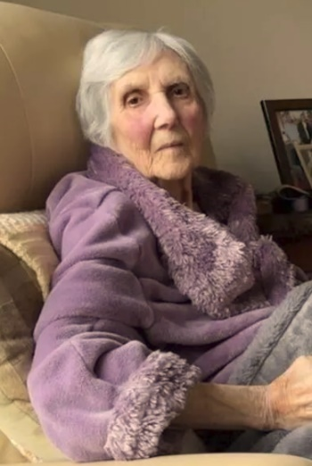
Vida was an Affiliate member of ANAVETS Sidney Museum Unit for 19 years (1996 through 2014) prior to the pandemic. Predeceased by husband Don Mann Life member and Past President BC Provincial Command and Sidney Unit 302.

Published January 26, 2026
In Loving Memory ~ Our beloved mother, Vida B Mann (Rust) passed away peacefully on January 17, 2026 at the age of 93. She was a force of nature, a source of wisdom and the heart of our family. Born and raised in Cranfield England, married Donald Mann August 11, 1956 celebrating 67 years together. She found joy in the simple things: a good book, her roses, her peach tree a quiet afternoon in her garden and a good cup of tea with friends and family. She was a dedicated wife, mother and her home was always filled with the warmth of her cooking. She will be profoundly missed by her children, Stuart, Sharon (Peter) and Stephen; her grandchildren Melanie and Tyson; and a circle of friends who loved her dearly. Now she can join Don her partner of life and be forever happy. According to Vida’s wishes there will be no service simply a small family gathering.

Read more at: https://peninsulanewsreview.com/2026/01/26/vida-b-mann-rust/

